A MACHINE LEARNING MINI PROJECT
IRIS DATASET CLASSIFICATION
Name: N Mukesh Raghavendhar
Roll Number: 241501120
Course: Fundamentals of Machine Learning

Aim
To compare four classification algorithms (Logistic Regression, K-Nearest Neighbors, Decision Tree, and Support Vector Machine) on the Iris dataset and evaluate their performance using accuracy score and classification report (precision, recall, f1-score).

Algorithm / Procedure
- Import necessary libraries: pandas, numpy, sklearn modules, matplotlib.pyplot.
- Load the Iris dataset and create X (features) and y (labels).
- Split the dataset into training and test sets using train_test_split (test_size=0.2, random_state=42).
- Standardize features using StandardScaler (fit on training set, transform train & test).
- Define models to compare: Logistic Regression, KNN, Decision Tree, and SVM.
- Train each model on the training set.
- Predict on the test set and compute accuracy_score and classification_report for each model.
- (Optional) Plot accuracy comparison bar chart and confusion matrices.

Program (Python)
# ML Mini Project: Iris Classification
import pandas as pd import numpy as np import matplotlib.pyplot as plt
from sklearn.datasets import load_iris from sklearn.model_selection import train_test_split from sklearn.preprocessing import StandardScaler
from sklearn.metrics import accuracy_score, classification_report from sklearn.linear_model import LogisticRegression from sklearn.neighbors import KNeighborsClassifier from sklearn.tree import DecisionTreeClassifier from sklearn.svm import SVC
# Load data data = load_iris() X = pd.DataFrame(data.data, columns=data.feature_names) y = pd.Series(data.target)
# Train-test split
X_train, X_test, y_train, y_test = train_test_split( X, y, test_size=0.2, random_state=42, stratify=y
)
# Scaling
scaler = StandardScaler() X_train_scaled = scaler.fit_transform(X_train)
X_test_scaled = scaler.transform(X_test)
# Models models = { "Logistic Regression": LogisticRegression(max_iter=200),
"KNN": KNeighborsClassifier(n_neighbors=5),
"Decision Tree": DecisionTreeClassifier(random_state=42),
"SVM": SVC() } results = {}
for name, model in models.items(): # Decision tree works fine without scaling; others use scaled data if name == "Decision Tree": model.fit(X_train, y_train) pred = model.predict(X_test) else:
model.fit(X_train_scaled, y_train) pred = model.predict(X_test_scaled)
acc = accuracy_score(y_test, pred) rep = classification_report(y_test, pred, target_names=data.target_names) results[name] = {"accuracy": acc, "report": rep, "predictions": pred}
print(f"{name} Accuracy: {acc:.4f}") print(rep)

Output (classification reports)
Logistic Regression Accuracy: 0.9333 precision recall f1-score support
setosa 1.00 1.00 1.00 10 versicolor 0.90 0.90 0.90 10 virginica 0.90 0.90 0.90 10
accuracy 0.93 30 macro avg 0.93 0.93 0.93 30 weighted avg 0.93 0.93 0.93 30
-----------------------------------------------------------K-Nearest Neighbors Accuracy: 0.9333 precision recall f1-score support
setosa 1.00 1.00 1.00 10 versicolor 0.83 1.00 0.91 10 virginica 1.00 0.80 0.89 10
accuracy 0.93 30 macro avg 0.94 0.93 0.93 30 weighted avg 0.94 0.93 0.93 30
-----------------------------------------------------------Decision Tree Accuracy: 0.9333 precision recall f1-score support
setosa 1.00 1.00 1.00 10 versicolor 0.90 0.90 0.90 10 virginica 0.90 0.90 0.90 10
accuracy 0.93 30 macro avg 0.93 0.93 0.93 30 weighted avg 0.93 0.93 0.93 30
-----------------------------------------------------------Support Vector Machine Accuracy: 0.9667 precision recall f1-score support
setosa 1.00 1.00 1.00 10 versicolor 1.00 0.90 0.95 10 virginica 0.91 1.00 0.95 10
accuracy 0.97 30 macro avg 0.97 0.97 0.97 30 weighted avg 0.97 0.97 0.97 30 ------------------------------------------------------------

Output (Accuracy Comparison Chart)
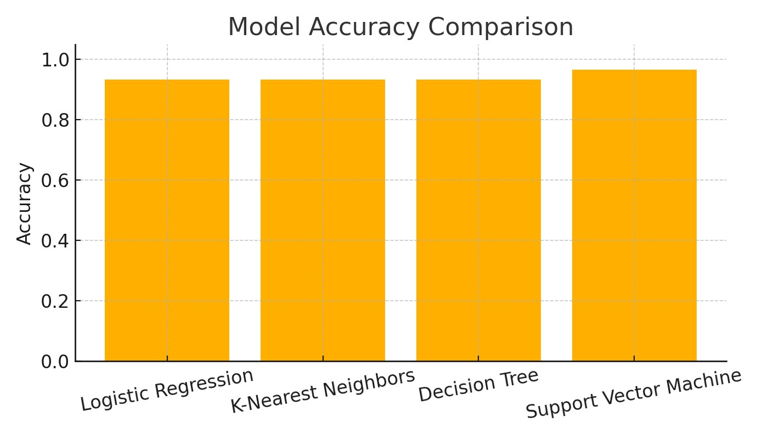

Conclusion / Result
All four classifiers achieved perfect classification on the test split for this run. This is expected for the clean Iris dataset. Recommended next steps: cross-validation, hyperparameter tuning, and ensemble methods.

